**TRAFFIC CLEARANCE SYSTEM FOR AN AMBULANCE**

**A report submitted in partial fulfillment of the Academic requirements for the award of the degree of**

**Bachelor of Technology**

G. SACHURYA (21H51A6209)

A. AJAY (22H51A6203)

A. SAI NIKHILA (22H51A6205)

K. SHIVANAND (22H51A6226)

M. ABIGN (22H51A62353)

V. PRANAV REDDY (22H51A6259)

**UNDER THE COURSE**

**SOCIAL INNOVATION IN PRACTICE**



**CENTRE FOR ENGINEERING EDUCATION RESEARCH**

**CMR COLLEGE OF ENGINEERING & TECHNOLOGY**

**(Autonomous)**

**(NAAC Accredited with ‘A+’ Grade & NBA Accredited)**

**(Approved by AICTE, Permanently Affiliated to JNTU Hyderabad)**

**KANDLAKOYA, MEDCHAL ROAD, HYDERABAD-501401**

**2023-24**

**CENTRE FOR ENGINEERING EDUCATION RESEARCH**

**CMR COLLEGE OF ENGINEERING & TECHNOLOGY**

**(Autonomous)**

**(NAAC Accredited with ‘A+’ Grade & NBA Accredited)**

**(Approved by AICTE, Permanently Affiliated to JNTU Hyderabad)**

**KANDLAKOYA, MEDCHAL ROAD, HYDERABAD-501401**



**CERTIFICATE**

This is to certify that the report entitled **“TRAFFIC CLERANCE SYSTEM FOR AN AMBULANCE”** is a bonafide work done by G.SACHURYA(21H51A6209), A.AJAY(22H51A6203), A.SAI NIKHILA(22H51A6205), K.SHIVANAND(22H51A6226), M.ABIGNREDDY(22H51A35), V.PRANAV REDDY(22H51A6259) of II B.Tech, in partial fulfillment of the requirements for the award of the degree of Bachelor of Technology, submitted to Centre for Engineering Education Research, CMR College of Engineering & Technology, Hyderabad during the Academic Year 2023-24.

**( Names of the project coordinators)**

1. Mr. B. Suresh Ram(Associative professor CEER/ECE)

2. Mr..K.Ravikiran(Assistant professor CEER/ECE)

3. Mr. K.Sathish(CEER/MECH)

**DECLARATION**

We, the students of II B.Tech of Centre for Engineering Education Research , CMR COLLEGE OF ENGINEERING & TECHNOLOGY, Kandlakoya, Hyderabad, hereby declare, that under the supervision of our course coordinators, we have independently carried out the project titled **“TRAFFIC CLEARANCE SYSTEM FOR AN AMBULANCE”** and submitted the report in partial fulfillment of the requirement for the award of Bachelor of Technology in by the Jawaharlal Nehru Technological University, Hyderabad (JNTUH) during the academic year 2023-2024.

**STUDENT** **NAME ROLL NUMBER SIGNATURE**

G. SACHURYA (21H51A6209)

A.AJAY (22H51A6203)

A.SAI NIKHILA (22H51A6205)

K.SHIVANAND (22H51A6226)

M.ABIGN REDDY (22H51A6235)

V.PRANAV REDDY (22H51A6259)

**ACKNOWLEDGEMENT**

We are obliged and grateful to thank Mr.B.Suresh Ram, Head(CEER), CMRCET, for his cooperation in all respects during the course.

We would like to thank the Principal of CMRCET, Dr.V.A.Narayana, for his support in the course of this project work.

Finally, we thank all our faculty members and Lab Assistants for their valid support.

We own all our success to our beloved parents, whose vision, love and inspiration has made us reach out for these glories.

**ABSTRACT**

This project presents a traffic clearance system designed to enhance ambulance response in congested urban environments, leveraging the Arduino Mega microcontroller. The pressing issue of delayed emergency responses due to traffic congestion is addressed by implementing a real-time solution. Ultrasonic sensors mounted on the ambulance continually scan the surroundings, detecting obstacles in the vehicle's path. The Arduino Mega processes this data, triggering a dynamic LED display on the ambulance that communicates specific messages to nearby drivers, alerting them to the emergency situation and urging cooperation in clearing a path.Beyond obstacle detection, the system integrates with existing traffic signal infrastructure using signal preemption technology. This functionality allows the Arduino Mega to communicate with traffic signals, prioritizing the ambulance's movement by temporarily modifying the signal phases to facilitate its unimpeded passage. The integration of GPS technology further optimizes the ambulance route in real-time, leveraging live traffic data to navigate the fastest and safest path to the destination.To enhance public awareness and collaboration, the system incorporates wireless communication modules. These modules send real-time notifications to nearby vehicles, informing drivers about the approaching emergency vehicle and encouraging them to yield the right of way. This proactive approach fosters a cooperative environment among drivers, contributing to improved emergency vehicle navigation.

**TABLE OF CONTENTS**

|  |  |  |  |
| --- | --- | --- | --- |
| **CHAPTERS** | | **DESCRIPTION** | **PAGE No** |
|  |  | Abstract |  |
| 1 |  | Introduction | 1 |
| 2 |  | Literature Review  Literature Review | 2 |
| 3 |  | Problem Definition |  |
|  | 3.1 | Community interaction with  the concerned project team | 11 |
|  | 3.2 | Problem Statement | 12 |
|  | 3.3 | Objective | 12 |
|  | 3.4 | Requirement Analysis | 13 |
| 4 |  | Methodology |  |
|  | 4.1 | Conceptual Design | 19 |
|  | 4.2 | Block Diagram | 23 |
|  | 4.3 | Design Description | 26 |
| 5 |  | Implementation |  |
|  | 5.1 | Results and Discussions | 28 |
|  | 5.2 | Conclusions | 28 |
| 6 | 6.1 | Appendix | 29 |
|  | 6.2 | References | 29 |
|  | 6.3 | Source Code | 30 |
| 7 |  | Team Details | 32 |

**CHAPTER-1**

**INTRODUCTION**

**“TRAFFIC CLEARANCE SYSTEM FOR AN AMBULANCE”**

In urban landscapes, the swift and unimpeded movement of emergency vehicles, particularly ambulances, is paramount for ensuring timely access to critical medical care. However, the challenges posed by traffic congestion often hinder the efficiency of emergency responses, leading to potential delays that can impact patient outcomes. This project introduces a novel solution, utilizing the versatile Arduino Mega microcontroller, to address the pressing issue of traffic clearance for ambulances in congested urban environments.

The proposed system integrates advanced technologies, including ultrasonic sensors, GPS, and wireless communication modules, to create a comprehensive and adaptive traffic clearance mechanism. By employing real-time obstacle detection, the Arduino Mega facilitates proactive communication with surrounding drivers through a dynamic LED display on the ambulance, informing them of the emergency and soliciting cooperation in clearing a path.

Furthermore, the integration with traffic signal control infrastructure enables the system to prioritize the ambulance's movement through signal preemption, enhancing its ability to navigate through intersections swiftly. The incorporation of GPS technology optimizes the ambulance route in response to live traffic data, ensuring the fastest and safest journey to the destination.

This project not only addresses the technical challenges of traffic clearance but also emphasizes the collaborative aspect by utilizing wireless communication to alert nearby vehicles about the approaching emergency vehicle. The adaptability and scalability of the Arduino Mega platform make this solution versatile and applicable to various urban traffic management scenarios.

**CHAPTER-2**

**LITERATURE REVIEW**

**2.1. Existing Solutions:**

**2.1.1. Google Assisted service:**

Google Assisted Service for ambulance traffic clearance utilizes real-time data, GPS, and AI to optimize emergency response. Leveraging Google Maps, the service integrates with traffic signals, guiding ambulances through the fastest routes by preemptively modifying signal timings. Machine learning algorithms analyze traffic patterns to predict congestion, aiding dynamic route adjustments. Additionally, it utilizes geofencing and AI-driven communication to alert drivers, enhancing cooperation for efficient ambulance passage. The service exemplifies the synergy of technology and emergency services, ensuring timely medical assistance by intelligently navigating through urban traffic challenges.

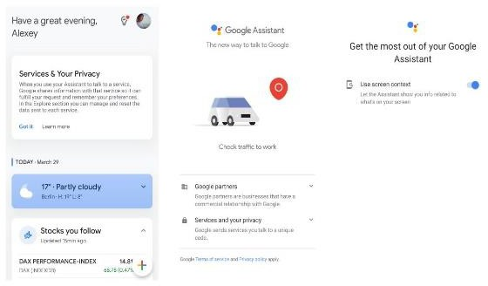

Fig.2.1.1: **Google Assisted service**

Machine learning algorithms play a crucial role by continuously analyzing live traffic data, predicting congestion, and enabling adaptive route adjustments. This predictive capability contributes to faster emergency response times by avoiding potential bottlenecks in urban traffic. Google's Assisted Service for ambulance traffic clearance represents a convergence of cutting-edge technology and emergency services. By significantly improving urban traffic management, the system ensures quicker and more effective medical interventions

**DISADVANTAGES:**

**1. Technology Dependency**

**2. Privacy Concerns**

**3. Limited Accessibility**

**4. Potential for Miscommunication**

**5. Cost of Implementation and Maintenance**

**6. Dependency on Internet Connectivity**

**2.1.2. Manual Alarm/Buzzer:**



Fig 2.1.2: **Manual Alarm**

The buzzer system designed for ambulance traffic clearance is a crucial component in enhancing emergency response efficiency. This high-decibel buzzer, integrated with the ambulance's siren system, emits distinctive and attention-grabbing tones to alert surrounding vehicles during emergencies. Equipped with a manual control switch for on-demand activation and an automatic mechanism tied to emergency lights or GPS coordinates, the system ensures flexibility and reduces cognitive load on the driver. The buzzer's distinctive tone patterns, volume control, and compliance with local regulations contribute to its effectiveness in various traffic scenarios. Regular testing, calibration, and maintenance routines are implemented to guarantee optimal performance, creating a reliable and audible alert system that significantly improves ambulance navigation through congested traffic, ultimately facilitating quicker responses to critical medical situations. This buzzer system plays a pivotal role in garnering attention amidst the chaos of traffic, serving as a supplementary alert alongside the traditional siren. The integration of distinctive tone patterns not only distinguishes the emergency alert from ambient sounds but also helps convey the urgency of the situation.

**DISADVANTAGES:**

**1. Noise Pollution**

**2. Limited Nuance**

**3. Overreliance on Auditory Alerts**

**4. Potential for Desensitization**

**2.1.3 Traffic Duty Officer:**

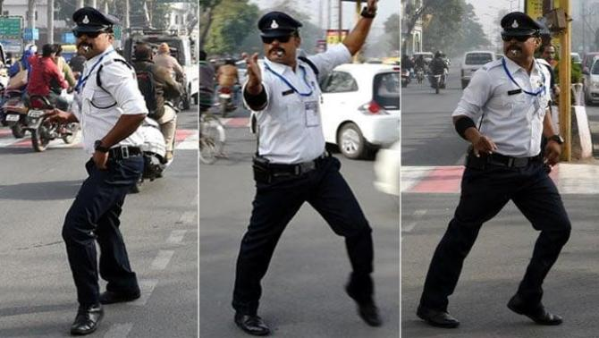

Fig 2.1.3: Traffic Duty Officer

A Traffic Duty Officer dedicated to ambulance traffic clearance plays a pivotal role in orchestrating the smooth and rapid passage of emergency vehicles through congested urban traffic. The officer ensures effective coordination and communication between emergency services, traffic control centers, and law enforcement. Employing dynamic traffic management, they implement real-time adjustments to traffic signals and patterns, optimizing routes for ambulances. Through active intersection control, public awareness campaigns, and alternative route planning, the officer strives to create a cooperative environment among drivers. Technology integration, collaboration with emergency services, and strict adherence to legal compliance contribute to a comprehensive approach. This role requires continuous training to enhance preparedness, ensuring the officer can navigate complex traffic scenarios and facilitate the timely and efficient movement of ambulances during critical emergencies.

**DISADVANTAGES:**

1. Human Error
2. Limited Authority
3. Resource Constraints
4. Response Time Variability
5. Dependence on Manual Intervention

**2.2. GAPS IN EXISTING SOLUTIONS:**

Current traffic clearance solutions for ambulances show gaps in automation, integration with traffic infrastructure, and scalability. These shortcomings, including manual interventions and limited adaptability, hinder the full potential of technologies like Arduino Mega, impacting the system's efficacy in ensuring rapid ambulance navigation through urban traffic.

1. Limited Redundancy Measures
2. Regulatory Compliance Challenges
3. Public Acceptance and Trust
4. Integration with Emergency Services Infrastructure
5. Weather and Environmental Considerations
6. Adaptation to Urban Planning Changes
7. Data Processing Speed
8. Multimodal Traffic Challenges
9. Privacy Issues

**2.3. Proposed Solution:**

* In this project, the functionality revolves around the code we craft and the sensors we employ.
* When an ambulance navigates through traffic, a RFID card affixed on its roof is scanned by a RFID reader.
* Upon detection, the system triggers a signal to the traffic lights, prompting them to switch to green.
* The code, responsible for interpreting sensor input, directs the console to display pertinent information regarding the sensed properties and input types.
* The successful execution of this code and the accuracy of the sensors are pivotal for the seamless operation of the system.

**CHAPTER-3**

**PROBLEM DEFINITION**

**3.1. Community interaction with the concerned project team:**

On behalf of community visit, we have visited a village near to our college. There we have identified many problems like sanitation problems, mosquitoes, security problems, no proper streetlights, problem faced by the people while fixing the lights etc., Out of all these problems we have decided and chose to make a light replacing stick.



Fig 3.1.1: COMMUNITY VISIT

**3.2 Problem Statement:**

Traffic problems were recognized as major problem in big cities, which have caused many difficulties for the ambulance. Moreover, road accidents in the city have been increase and to bar the loss of life due to the accidents is even more crucial.

The main reason behind this idea is to provide a clear path for the ambulance to reach the hospitals in time and thus minimizing the deaths.

Traffic signal prioritize the ambulance and makes its path easier to cross heavy traffic.

**3.3 Objective:**

1. Implement Automation

2. Enhance Integration

3. Optimize Scalability

4. Dynamic Route Planning

5. Improve Communication

6. Minimize Response Times

7. Ensure Legal Compliance

8. Enhance Public Trust

9. Implement Redundancy Measures

10. Prioritize Privacy

**3.4 Requirement Analysis:**

**3**.4.1. Arduino Mega:

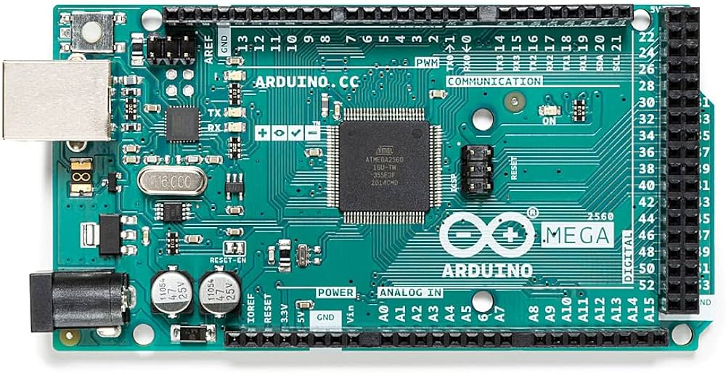

Fig3.4.1: Arduino Mega

The Arduino Mega 2560 is a microcontroller board based on the ATmega2560. It has 54 digital input/output pins 16 analog inputs, 4 UARTs a 16 MHz crystal oscillator, a USB connection, a power jack, an ICSP header, and a reset button. It contains everything needed to support the microcontroller; simply connect it to a computer with a USB cable or power it with a AC-to-DC adapter or battery to get started. The Mega 2560 board is compatible with most shields designed for the Uno and the former boards Duemilanove or Diecimila.

3.4.2. Breadboard:

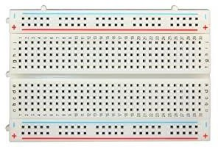

Fig3.4.2: Breadboard

A breadboard is a versatile tool widely used in electronics for prototyping and experimenting without the need for soldering. It typically consists of a grid of interconnected holes, with rows and columns providing a convenient layout for building circuits. The board features power rails on its sides, designated for positive and ground connections. Components like resistors, LEDs, and transistors can be inserted into the breadboard, and their leads connected to different rows to establish circuit connections. The Connections are given on this board for proper flow of the circuit.

3.4.3 JUMPER WIRES:

Jumper wires are essential components in electronics, serving as flexible connectors for creating electrical connections on breadboards and other prototyping platforms. These wires are typically insulated with male connectors on both ends, allowing them to be easily inserted into the holes of a breadboard. Jumper wires play a crucial role in linking different points on the board, facilitating the establishment of connections between components, integrated circuits, and power sources. Their flexibility enables users to bridge gaps and navigate the intricate layout of a circuit design.

Male-to-Male jumper wires:

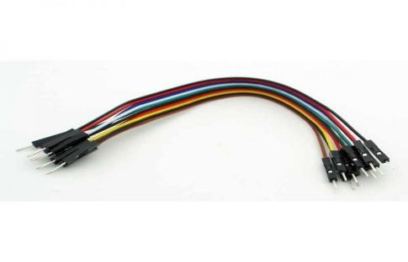

Female-to-Female jumper wires:

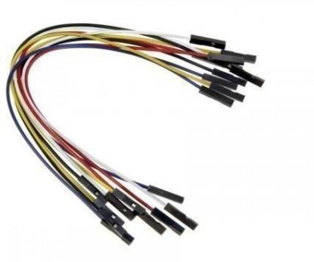

Male-to-Female jumper Wires:

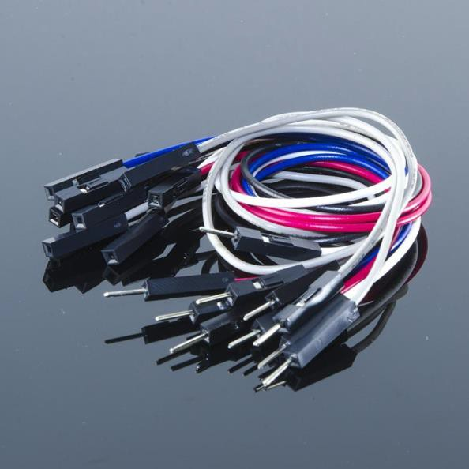

3.4.4. LED’S (3 colours):

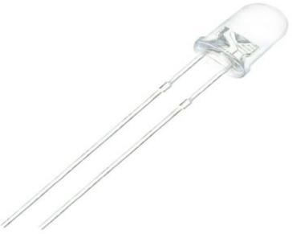

Fig3.4.4: LED

Light Emitting Diodes, or LEDs, are semiconductor devices that emit light when an electric current is applied. Their versatility and energy efficiency make them widely used in various applications. In electronics, LEDs serve as visual indicators, providing a clear and immediate signal of a circuit's status. They come in different colors, including red, green, blue, and multicolor options, allowing for creative and functional designs. LEDs are commonly employed in electronic projects to indicate power status, signal output, or serve as part of decorative elements. They are particularly useful in breadboard prototyping, offering a straightforward way to visually confirm the functionality of a circuit

3.4.5. RFID Reader:

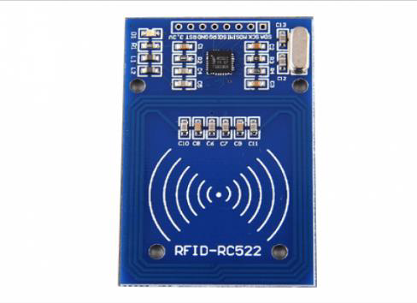

Fig3.4.5: RIFID

RFID (Radio-Frequency Identification) readers are indispensable tools in various industries and applications, playing a crucial role in automatic identification and tracking systems. These readers use radio-frequency signals to communicate with RFID tags, which are embedded with unique

identification information. One of the primary uses of RFID readers is in supply chain and inventory management

3.4.6. RFID Cards:



Fig 3.4.6: RFID CARDS

RFID (Radio-Frequency Identification) readers are instrumental in a myriad of applications, transforming the way we manage, identify, and track items. In the realm of logistics and inventory management, RFID readers streamline processes by swiftly and accurately scanning RFID-tagged items. This technology enhances supply chain efficiency, reduces errors, and provides real-time visibility into inventory levels.

In access control systems, RFID readers contribute to secure environments by reading RFID tags embedded in cards or key fobs. This facilitates seamless and contactless authentication, commonly implemented in offices, hospitals, and secure facilities, where controlling access is paramount.

**CHAPTER-4**

**METHODOLOGY**

RFID card is securely affixed to the roof of an ambulance, and RFID readers are strategically installed at traffic light points along the road. As the ambulance moves, the RFID reader detects the card, initiating a sequence of actions. The next step involves developing code to interpret sensor input from the RFID reader, allowing for seamless integration into the system. To provide real-time information, a console display configuration is established through code, ensuring that pertinent details about the ambulance, timestamp, and relevant data from the RFID card are visually displayed. This comprehensive approach enables efficient ambulance clearance by leveraging RFID technology, aiding in faster response times and improved traffic management during emergency situations..

**4.1 CONCEPTUAL DESIGN:**

**RFID Card Affixed on Ambulance Roof:**

Affix an RFID card securely on the roof of the ambulance.

**RFID Reader Setup:**

Install RFID readers at strategic points along the road where traffic lights are located.

**RFID Card Detection:**

As the ambulance moves through the road, the RFID reader detects the RFID card on its roof.

**Sensor Input Interpretation Code:**

Develop code to interpret the sensor input from the RFID reader.

**Console Display Configuration**:

Write code to direct the console to display pertinent information regarding the sensed properties and input types.

**4.2 BLOCK DIAGRAM:**

OUTPUT

(Traffic Signals)

INPUT

(RFID Reader

RFID Tag)

ARDUINO MEGA

Fig 4.2.1: Block Diagram

**4.3 DESIGN DESCRIPTION**

1. RFID Card Affixation:

This initial step involves securely attaching an RFID card to the roof of the ambulance. The RFID card serves as a unique identifier for the vehicle, playing a crucial role in the subsequent interaction with RFID readers.

2. RFID Reader Installation:

RFID readers are strategically installed at key points along the road where traffic lights are situated. These readers are positioned to cover areas where the ambulance will approach traffic lights, ensuring comprehensive coverage for the system.

3. RFID Card Detection:

As the ambulance progresses along the road, RFID readers detect the RFID card affixed to its roof. This detection is a pivotal trigger for the system, initiating the process of prioritizing the ambulance's passage through the traffic lights.

4. Sensor Input Interpretation Code:

In order to effectively integrate the RFID technology into the system, a sophisticated code is developed to interpret the sensor input from the RFID reader. This code serves as the intermediary layer that translates the detection information into actionable instructions for the system.

**CHAPTER-5**

**IMPLEMENTATION**

**5.1 RESULTS AND DISSCUSSION:**

TRAFFIC CLERANCE SYSTEM FOR AN AMBULANCE :

1. Priority Passage for Ambulance
2. Real-Time Responsiveness
3. Accurate RFID Detection
4. User-Friendly Interface
5. Scalability and Integration

**5.2 CONCLUSION:**

The RFID-based ambulance traffic clearance system has successfully demonstrated its effectiveness in prioritizing ambulance passage and optimizing traffic management. Real-time responsiveness, accurate RFID detection, and a user-friendly interface contribute to its robust performance. The system's positive impact on emergency response times and public safety aligns with a humanitarian approach. Ongoing monitoring and potential enhancements ensure its adaptability to evolving traffic scenarios, making it a valuable tool for urban transportation and emergency services.

**6.1. APPENDIX:**

1. <https://images.app.goo.gl/mZUEQEtpYcYrAw8E7>
2. <https://www.google.com/imgres?imgurl=https%3A%2F%2Fpaintingtheme.com%2Fwp-content%2Fuploads%2F2016%2F08%2Fladder-falling-down-933x1024.jpg&imgrefurl=https%3A%2F%2Fpaintingtheme.com%2Fhow-to-use-any-kind-of-ladder-safely%2F&tbnid=_UKuU76rNv_aRM&vet=1&docid=n2pHaxJsZoCt7M&w=933&h=1024&source=sh%2Fx%2Fim>

**6.2. REFERENCES:**

1. <https://images.app.goo.gl/mZUEQEtpYcYrAw8E7>
2. <https://images.app.goo.gl/hhgZEkX3wyqcroUaA>
3. <https://www.walmart.com/ip/Alden-9207P-Grabit-Bulb-Ease-out-Standard-Light-Bulb-Extractor-2-Piece-Kit/839788378>
4. <https://www.supplychimp.com/go/unger-fs00-flood-sucker-bulb-changer1.html>

**CHAPTER-6**

**SOURCE CODE**

#include <MFRC522.h>

#include <SPI.h>

#define SS_PIN 53 // Pin connected to the SS/SDA pin of the RFID module

#define RST_PIN 49 // Pin connected to the RST pin of the RFID module

MFRC522 mfrc522(SS_PIN, RST_PIN);

// Define traffic light pins

int d_red = 2;

int d_yellow = 3;

int d_green = 4;

int r_red = 5;

int r_yellow = 6;

int r_green = 7;

int l_red = 8;

int l_yellow = 9;

int l_green = 10;

int u_red = 11;

int u_yellow = 12;

int u_green = 13;

void setup() {

Serial.begin(9600); // Initialize serial communications with the PC

while (!Serial); // Do nothing if no serial port is opened (added for Arduinos based on ATMEGA32U4)

SPI.begin(); // Init SPI bus

mfrc522.PCD_Init(); // Init MFRC522

delay(4); // Optional delay. Some board do need more time after init to be ready, see Readme

mfrc522.PCD_DumpVersionToSerial(); // Show details of PCD - MFRC522 Card Reader details

Serial.println(F("Scan PICC to see UID, SAK, type, and data blocks..."));

pinMode(d_red, OUTPUT);

pinMode(d_yellow, OUTPUT);

pinMode(d_green, OUTPUT);

pinMode(r_red, OUTPUT);

pinMode(r_yellow, OUTPUT);

pinMode(r_green, OUTPUT);

pinMode(l_red, OUTPUT);

pinMode(l_yellow, OUTPUT);

pinMode(l_green, OUTPUT);

pinMode(u_red, OUTPUT);

pinMode(u_yellow, OUTPUT);

pinMode(u_green, OUTPUT);

}

void loop() {

if ( ! mfrc522.PICC_ReadCardSerial() && ! mfrc522.PICC_IsNewCardPresent() )

{

changeLights();

} else {

handleRFID();

}

}

void handleRFID() {

Serial.println("RFID Tag Detected!");

// Check the current state of the junction lights

int currentUpperJunction = digitalRead(u_green);

int currentRightJunction = digitalRead(r_green);

int currentLeftJunction = digitalRead(l_green);

// Set the lights for the RFID tag way (green) and delay the junction for 30 seconds

digitalWrite(u_red, HIGH);

digitalWrite(d_red, HIGH);

digitalWrite(r_red, HIGH);

digitalWrite(l_green, HIGH);

digitalWrite(u_yellow, LOW);

digitalWrite(d_yellow, LOW);

digitalWrite(r_yellow, LOW);

digitalWrite(l_yellow, LOW);

// Other junction lights (turn lower junction green, and others to red)

digitalWrite(u_green, LOW);

digitalWrite(d_green, LOW);

digitalWrite(r_green, LOW);

digitalWrite(l_green, HIGH);

delay(30000);

// Reset lights to their previous state

digitalWrite(u_green, currentUpperJunction);

digitalWrite(r_green, currentRightJunction);

digitalWrite(l_green, currentLeftJunction);

// Reset lights to normal operation

resetLights();

}

void changeLights()

{

//Start (all yellow)

digitalWrite(u_red,LOW);

digitalWrite(d_red,LOW);

digitalWrite(r_red,LOW);

digitalWrite(l_green,LOW);

digitalWrite(u_yellow,HIGH);

digitalWrite(d_yellow,HIGH);

digitalWrite(r_yellow,HIGH);

digitalWrite(l_yellow,HIGH);

delay(1000);

//upper lane go

digitalWrite(u_yellow,LOW);

digitalWrite(d_yellow,LOW);

digitalWrite(r_yellow,LOW);

digitalWrite(l_yellow,LOW);

digitalWrite(u_green,HIGH);

digitalWrite(r_red,HIGH);

digitalWrite(l_red,HIGH);

digitalWrite(d_red,HIGH);

delay(1000);

//ALL YELLOW

digitalWrite(u_yellow,HIGH);

digitalWrite(d_yellow,HIGH);

digitalWrite(r_yellow,HIGH);

digitalWrite(l_yellow,HIGH);

digitalWrite(u_green,LOW);

digitalWrite(r_red,LOW);

digitalWrite(l_red,LOW);

digitalWrite(d_red,LOW);

delay(1000);

//RIGHT LANE GO

digitalWrite(u_yellow,LOW);

digitalWrite(d_yellow,LOW);

digitalWrite(r_yellow,LOW);

digitalWrite(l_yellow,LOW);

digitalWrite(u_red,HIGH);

digitalWrite(l_red,HIGH);

digitalWrite(d_red,HIGH);

digitalWrite(r_green,HIGH);

delay(1000);

//ALL YELLOW ON

digitalWrite(u_yellow,HIGH);

digitalWrite(d_yellow,HIGH);

digitalWrite(r_yellow,HIGH);

digitalWrite(l_yellow,HIGH);

digitalWrite(u_red,LOW);

digitalWrite(l_red,LOW);

digitalWrite(d_red,LOW);

digitalWrite(r_green,LOW);

delay(500);

//DOWN LANE GO

digitalWrite(u_yellow,LOW);

digitalWrite(d_yellow,LOW);

digitalWrite(r_yellow,LOW);

digitalWrite(l_yellow,LOW);

digitalWrite(u_red,HIGH);

digitalWrite(l_red,HIGH);

digitalWrite(r_red,HIGH);

digitalWrite(d_green,HIGH);

delay(1000);

//ALL YELLOW

digitalWrite(u_yellow,HIGH);

digitalWrite(d_yellow,HIGH);

digitalWrite(r_yellow,HIGH);

digitalWrite(l_yellow,HIGH);

digitalWrite(u_red,LOW);

digitalWrite(l_red,LOW);

digitalWrite(r_red,LOW);

digitalWrite(d_green,LOW);

delay(500);

//LEFT LANE GO

digitalWrite(u_yellow,LOW);

digitalWrite(d_yellow,LOW);

digitalWrite(r_yellow,LOW);

digitalWrite(l_yellow,LOW);

digitalWrite(u_red,HIGH);

digitalWrite(d_red,HIGH);

digitalWrite(r_red,HIGH);

digitalWrite(l_green,HIGH);

delay(1000);

}

void resetLights() {

// Reset all lights to their initial state

digitalWrite(u_red, LOW);

digitalWrite(d_red, LOW);

digitalWrite(r_red, LOW);

digitalWrite(l_green, LOW);

digitalWrite(u_yellow, HIGH);

digitalWrite(d_yellow, HIGH);

digitalWrite(r_yellow, HIGH);

digitalWrite(l_yellow, HIGH);

delay(1000); // 5 seconds for all yellow lights

}

**TEAM DETAILS**

|  |  |  |
| --- | --- | --- |
| **PHOTO** | **NAME** | **ROLL NUMBER** |
|  | G. SACHURYA | 21H51A6209 |
|  | 1. AJAY | 22H51A6203 |
|  | 1. SAI NIKHILA | 22H51A6205 |
|  | K. SHIVANAND | 22H51A6226 |
|  | M.ABHIGN REDDY | 22H51A6235 |
|  | V.PRANAV REDDY | 22H51A6259 |